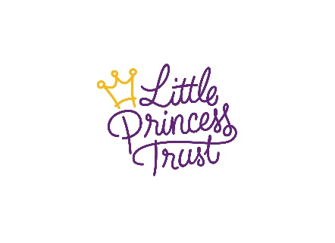
Keeping Fundraising Safe and Legal
Your safety and wellbeing is our priority, so with this in mind, please follow these fundraising guidelines and ensure you adhere to all laws and health and safety regulations when organising and holding your event. If you have any questions, please contact us, we’re here to help!

If you are under 18
If you’re aged under 18, you must have your parent or guardian's permission to fundraise.

Children at your event
Make sure children are properly looked after and have permission to take part from a parent or guardian.
Ensure that your event is properly and adequately supervised. Where children are involved, this should include providing proper adult supervision and carrying out appropriate background checks if adults are to have unsupervised access to children. See the Government's Disclosure and Barring Service (DBS) for more guidance.
You must not give children under 16 overall responsibility for handling money or responsibility for counting collected money.
Under 16’s are not permitted to collect money through public collections.

Photos and Videos
If you’re planning to take photos or videos at your event, please get permission from everyone involved.
You must get permission before taking or publishing photographs of children. Children should always be consulted about the use of their image and give consent to it being used and shared. If the child is over 13 years old they can give this permission themselves. If they are under 13, you must get permission from their parent or guardian.

Permission
It is very important to make sure you have the right permissions to hold your event at its venue. If you’re planning to fundraise or hold an event in a public place, you must get permission first, either from the local authority or the property owner/manager.

Licences
For some fundraising activity you will require a licence, such as:
- doing a public money collection
- holding a raffle, lottery or auction
- alcohol or entertainment, including recorded music
- putting up banners or signs in public areas.
This list doesn’t cover everything. Please ask your local authority whether or not you need to obtain any special licences.

Liability and Insurance
Please make sure that it is clear that you are fundraising in aid of The Little Princess Trust and that your activities are not representing or organised by the charity. The charity cannot accept any responsibility for your event or anyone who participates in it.
If your event involves the general public, it’s important to have Public Liability Insurance in place. Check with the venue first as they may already have insurance that covers your event. If you’re holding an event at home or on private property, check your insurance covers this too.

Data Protection
Only collect the information you need. Keep it safe, do not share it, only use it for the purpose(s) for which it was given, and only keep it for as long as you need it. You can find information about how we protect and use personal data in our privacy policy which is on our website. You can also find more information at the Information Commissioner's Office.

Handling money and keeping safe
- Please always make sure an adult is present when handling and counting cash. Children under 16 must not be left with overall responsibility for handling money or for counting collected money.
- Ensure there are two people present when money is being handled and counted. Ideally two unrelated people.
- We recommend using a cash box with a lock or a sealed collection bucket when taking payments or donations to keep it secure. Never leave cash unattended.
- It’s strongly advisable to have two people available to transport cash and take it to a bank as soon as possible after the event. Always try to conceal cash when you are transporting it and travel using the safest route possible.
- If you're ever confronted by someone demanding the cash, just hand over the money and don't put up a fight. This should then be reported to the police as soon as possible.
- Please put money in the bank as soon as possible. Please see our website for details of how to send the money to us https://www.littleprincesses.org.uk/donate-money

Transfer of funds
- All money raised in aid of The Little Princess Trust should be sent us as soon as practically possible and must be sent to us within four weeks of collection.
- Expenses must not be deducted from the sums collected unless you have approved this with us, provided us with a receipt, and made this clear to your sponsors or donors.

Thank for supporting The Little Princess Trust!

